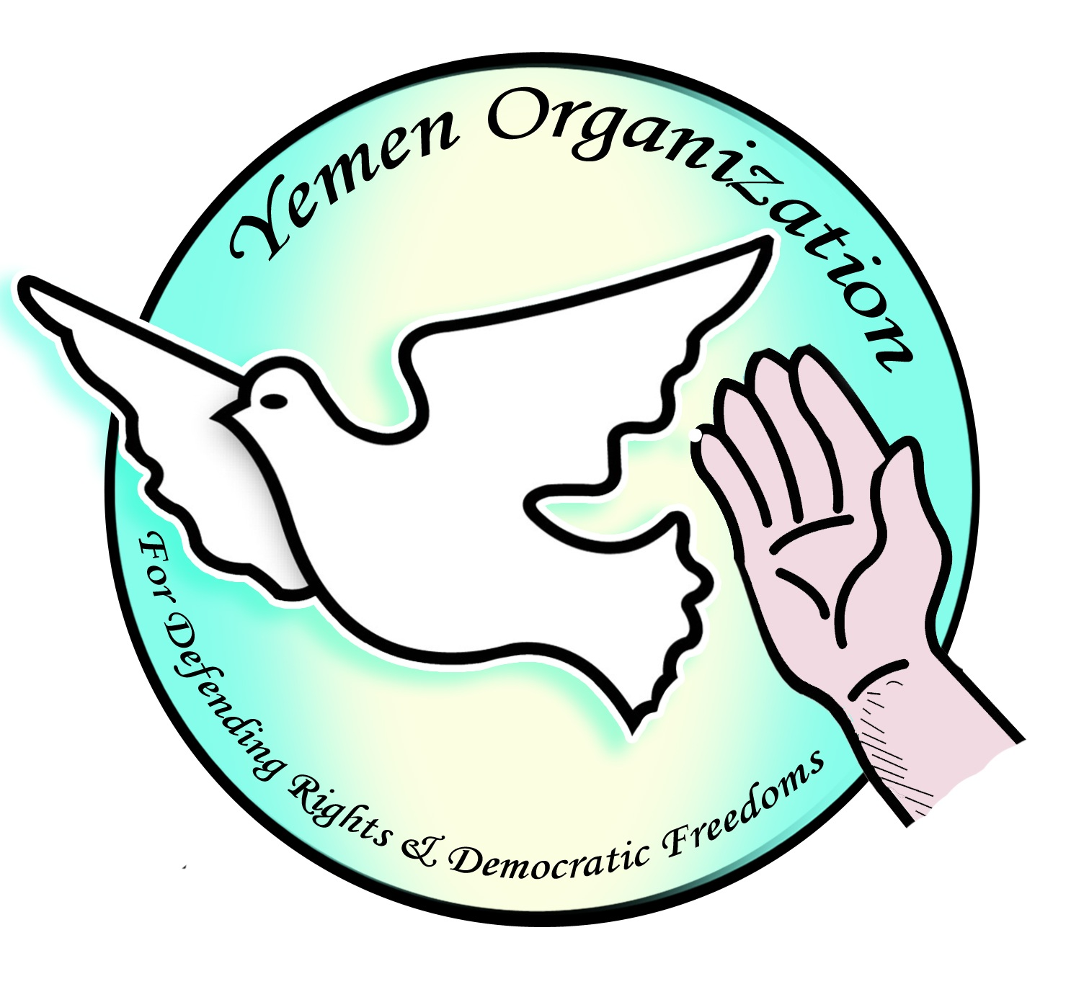 

**Women’s Rights in Yemen:**

**Joint NGO Stakeholder Report for the UN Universal Periodic Review**

submitted June 2013 to the UN Office of the High Commissioner for Human Rights

*by Yemen Organization for Defending Rights and Democratic Freedoms*

*in collaboration with Karama*

**Yemen Organization for Defending Rights & Democratic Freedoms** is a non-governmental organization based in Yemen, working on a local and regional level. Founded in 1993 and launching its activities significantly in 2000, the organization was able to get a license in 2012 after the revolution in Yemen. Our Mission is to enhance, support, promote and defend basic principles of Human Rights for all people no matter their race, gender, or ethnicity. Our Vision is to be an efficient and transparent non-profit organization that focuses on human rights issues in Yemen, reaching and supporting victims around the country, and strongly seeking to change practice and policy of those violating Human Rights. The importance of establishing such an organization comes from the need to have a national role in supporting and protecting freedoms and rights, commitment to the constitution, and binding under laws. The importance extends to observing and registering violations such as forced disappearance, torture, political arrests, discrimination, unfair trials, trials that are unconstitutional, freedom from rights violations, and freedom of religious beliefs. It is considered a basic principle in our vision to develop the civil and democratic rights. Yemen Organization for Defending Rights & Democratic Freedoms is not registered as an ECOSOC NGO, however, in 2009, the organization participated in Yemen’s UPR session under the auspices of the Cairo Institute for Human Rights, and in 2013 had an NGO delegate at the UN Commission on the Status of Women, in a delegation coordinated by Karama under the auspices of Equality Now.

**Karama** is a regional NGO based in Cairo, Egypt, with an office in Amman, Jordan. Operating throughout the MENA region, Karama has built a coalition with partners in fourteen countries—including Algeria, Egypt, Iraq, Jordan, Lebanon, Libya, Morocco, Palestine, Somalia, South Sudan, Sudan, Syria, Tunisia, and Yemen. Karama works with women, men, youth, academics, activists, community leaders, politicians, parliamentarians, and others in an effort to cancel or reform discriminatory laws and practices and promote women’s advancement, security, and protection in all aspects of public and private life, by providing training, resources, convening, advocacy, lobbying, and media work for our partners. Since 2005, Karama has affected advocacy, capacity-building, knowledge-sharing and exchange, and policymaking at the national, regional, and international levels. Karama is not an ECOSOC NGO. Through collaboration with partners that are ECOSOC NGOs such as Equality Now, Alliance for Arab Women, UAF, and WILPF, Karama has coordinated regional delegations of Arab women’s rights NGOs to sessions of the UN Commission on Women, the CEDAW Committee, the Human Rights Council and the Universal Periodic Review.

**Yemen Organization for Defending Rights and Democratic Freedoms**

Sana’a, Yemen

Tel: 00967 1 562662

Fax: 00967 1 562655

Email: [emadj2333@gmail.com](mailto:emadj2333@gmail.com)

[yemeniorganization@gmail.com](mailto:yemeniorganization@gmail.com)

Web: <http://www.hurryat.org>

**Karama**

48 El Thawra Street, Floor 7, Apt 71

Dokki, Giza

Egypt

T/F: +(202) 33368137 / 33363204 / 37480188

Email: [info@karama.org](mailto:info@karama.org)

[sarah@el-karama.org](mailto:sarah@el-karama.org)

Web: <http://www.el-karama.org>

**Women's Rights in Yemen**  
**Joint NGO Stakeholder Report for the Universal Periodic Review of Yemen**

June 2013

submitted to the UN Office of the High Commissioner for Human Rights   
 by Yemen Organization for Defending Rights and Democratic Freedoms

in collaboration with Karama

**1. Introduction**

* 1. Over the years Yemeni women have fought strongly to gain their rights—political, economic, social and legal. With ratification of CEDAW in 1984 and the passage of the Yemen Constitution in 1990*,* women succeeded in obtaining certain constitutional rights to equality:

- Article (25) states that the Yemeni society is based on social solidarity (based on justice, freedom and equality and in accordance with the law)

- Article (41) states that all citizens are equal in rights and duties.

The Constitution is the supreme source of legal rights in Yemen.

* 1. With these rights, women surpassed many traditional societal barriers they faced and overcame society’s view of women as second-class citizens. This struggle culminated with women’s active participation in the Yemeni revolution in 2011.
  2. For months, women had a strong presence and participated ardently in the revolution. Because Yemen is considered a more conservative country in comparison with Egypt and Tunisia, women’s role in the revolution was itself an important achievement, elevating the intellectual and cultural status of women in tribal society. Women’s presence in Yemen’s rcvolution exceeded the role of women in other countries in the Arab Spring, enough to draw the attention of the world.
  3. During the revolution, women participated in protest activities side by side with male colleagues, including active participation in marches in which they faced several kinds of abuse, such as insults, beatings and kidnapping. Especially in Taiz and Sana’a, women were injured and killed, including Aziza Osman, Apple Tfaha, Yasmin Ali, Saw Alblhouli among many others.
  4. In a key step in this struggle, women succeeded in demanding a quota of 30 percent of the seats in the National Dialogue Conference, in which all parties participating in the conference fulfilled this percentage of women on their lists. With this quota of women in effect, the National Dialogue will draft the new constitution, and should guarantee equal citizenship and enhance women’s participation and political representation.
  5. Despite attaining 30 percent of the National Dialogue, women’s struggle still has a long path in order to achieve their human rights. Additional challenges to face include: overcoming prejudicial cultural mindsets, constitutionalizing women’s rights, abolishing laws that discriminate against women, and raising awareness in Yemeni women themselves of their political, social, economic and cultural rights. The most important challenge for the National Dialogue Conference and the Yemeni civil society is to ensure that the principles of gender equality, non-discrimination, and human rights are embedded in the new constitution and not just in individual laws, in order to protect and strengthen the integrity of this goal for the people.
  6. According to Amnesty International in a special 2009 campaign report[1], women in Yemen are subject to discrimination and rampant violence, with harsh results on women’s lives. Women’s rights are violated routinely because laws as well as tribal and customary practices look upon women as second-class citizens.

1. **Recommendations**

To address these challenges, the NGO authors of this report make the following recommendations.

* 1. Ensure the full rights of women under international conventions and treaties ratified by Yemen in the drafting of the new constitution and in the laws enacted from the results of the National Dialogue in Yemen.
  2. Cancel Yemen’s reservation on CEDAW Article 29, on the settlement of disputes concerning the application and interpretation of the convention.
  3. Pass a law for a system of quotas to ensure that women are represented in 30% of seats in all decision-making positions, and increase the number of women in executive and judicial positions in the transitional phase.
  4. Develop policies, mechanisms, and programs to enable the largest number of women to hold public offices pursuant to full and equal civil and political rights, and thereby to reduce the gap between men and women in public offices.
  5. Foster the development of working women, make them aware of their rights, and give them equality, justice and opportunity.
  6. Find appropriate mechanisms (policies and programs) to ensure the activation of the Compulsory Education Law to reduce the phenomenon of high illiteracy and attrition, especially among girls.
  7. Repeal all discriminatory provisions against women in all legislation, especially in the Personal Status Law and Nationality Law, and ensure equal rights for women and men.
  8. Pass laws to protect women from domestic violence and criminalize this form of violence.
  9. Provide a database and official statistics on the phenomenon of violence against women in Yemen.
  10. Repeal mitigating factors, lower standards, and lessened sentences in the current Penal Code for honor killings; prosecute perpetrators of honor killings under the criminal code for murder and homicide without allowing extenuating conditions.
  11. Pass the law to prevent and criminalize the marriage of minors, setting 18 as the minimum age for marriage for males and females, and criminalize the female genital mutilation (FGM) of girls.
  12. Issue bylaws and clear procedures for application of the Personal Status Law, and ensure equal rights for women and men.
  13. Provide a human rights standard of treatment, security, and conditions in prison for all inmates, especially women. Enforce due process of law for all women in detention; issue formal charges and ensure a fair trial.
  14. Amend laws regarding journalists and activists, in order to fulfill the full scope of Article 6 in the Constitution which guarantees their freedom of expression and opinion; protect female activists and journalists from harassment and intimidation exercised with impunity for their opinions and speech, and protect female citizens’ freedom of expression in their manner of dress and speech.[2]

**Main Issues of Concern**

1. **Women’s political representation is weak**
   1. Now in the transitional phase Yemen is undergoing, women’s status remains the same - except for representation in the National Dialogue Conference. As women’s political representation is still weak, the continuing concern is that new power will replicate the former regime’s practice of marginalizing women’s role and presence in decision-making positions, keeping her representation as a figurehead only (and not representing the real impact of women's political representation). Especially with the approach of upcoming parliamentary elections in 2014, the current authorities have not yet involved women in the process. Also, looking at political parties and women’s role within their membership, central, and executive committees, women were given few seats.
   2. Despite the low percentage of women in decision-making positions, women have participated in the political process leading up to today. In the 2006 election for seats in the provincial and district councils, women were 46% of all voters.[3] However, at the provincial level, only 22 women were candidates for 333 seats; six won, taking 1.8% of the seats. For the 5620 district council seats, 125 women ran in the elections, and 27 won, winning just 0.48% of the seats. This indicates how the political parties encourage women to vote but not to run as candidates.
   3. Since the revolution, women’s representation in public office has not improved. The number of presidential appointments is a real indicator that women remain a minority in the decision making process. Only 3 women ministers were appointed to the reconciliation government in 2012 among a total of 34 ministers; of them, only 2 have portfolios and 1 works directly for the Cabinet without portfolio. Only 1 woman was appointed as a deputy Minister, and just one woman was named as a consultant to H.E the President of the Republic. Eighteen women serve as undersecretaries of the Ministries whereas 550 men hold the same post. Most in these positions were appointed during the former regime, so the revolution has not yet netted any improvement in the representation of women in these positions within decision-making structures.
   4. The past ten years have witnessed a noticeable increase in the activities of civil society organizations to empower women politically through political dialogues with the parties, parliament, and government to implement the quota system. Nevertheless, to date, these dialogues have not ensured an increase in the proportion of women's representation politically and in public life at the middle and highest levels of government.
   5. ***Recommendation****:* Pass a law for a system of quotas to ensure that women are represented in 30% of seats in all decision-making positions, and increase the number of women in executive and judicial positions in the transitional phase.
   6. ***Recommendation****:* Develop policies, mechanisms, and programs to enable the largest number of women to hold public office pursuant to the full and equal civil and political rights and thereby to reduce the gap between men and women.
2. **Women’s economic rights are weak**  
   1. Women’s economic situation is not different from their political empowerment in Yemen— remaining low as indicated in the 2012 World Bank report on Yemen, “Facing Hard Facts in Yemen.” Although females represent 49.3% of the total population, the rate of participation of women in economic activities is still at its lowest levels (9.9%). Within this number, 67% of women workers confirmed they face discrimination with regard to job advancement, and male domination of most employment opportunities in all the organs of the state.[4] Inexplicably, the unemployment rate among females who are able to work is disproportionately high—40.2% of women able to work are unemployed versus 11.3% unemployment in males who are able to work.[5]
   2. The Yemen government has not adhered to the application of the principle of equality in the granting of employment opportunities and career advancement for women and men, and the lack of a compulsory education law especially for girls in rural areas contributes significantly to women’s lack of opportunity in the labor market overall.
   3. The illiteracy rate among women in Yemen is 60.1% versus 27.3% of males. In rural areas the illiteracy rate among women is estimated to be 80.56%, while in urban areas 40.25% of women are illiterate. Seven out of every ten women at age 15 suffer from illiteracy, according to the 2013 UN Development Report.
   4. According to the World Economic Forum, the gender-based disparities in Yemen are the highest of 135 countries ranked in the 2012 Global Gender Gap Index on women’s economic and political status, education, and health.
   5. ***Recommendation***: Foster the development of working women, make them aware of their rights, and give them equality, justice and opportunity.
   6. ***Recommendation****:* Find appropriate mechanisms (policies and programs) to ensure the activation of the Compulsory Education Law to reduce the phenomenon of high illiteracy and attrition, especially among girls.
3. **Women’s rights for Yemeni nationality are unequal**
   1. In a positive step, Law 25 in 2010 granted Yemeni nationality automatically to any child of a Yemeni mother or father married to a foreigner. However, the law placed discriminatory conditions on any future marriages with regard to this right: as of 2010, if a Yemeni male wishes to marry a foreigner, he must only notify the Ministry of Interior. If a Yemeni woman wishes to marry a foreigner, she has to receive a formal approval from the Ministry of Interior. This creates uncertainty that, without this approval, her children will not be given Yemeni nationality, even if born and living in Yemen.
   2. Law 25 is not only discriminating between men and women, but also represents a violation of the aforementioned articles 25 and 41 of the Constitution. Articles 25 and 41 make the promise of gender equality and equal rights for all, yet Law 25 contradicts these articles by establishing an unequal condition for certain women with regard to marriage and nationality. The requirement to obtain permission for the marriage from the Minister of the Interior puts Yemeni women and their children in a precarious position to which Yemeni men and their children are not subjected, and creates different classes of women in this category: those who married a foreigner before 2010 when the law came into force and whose children were granted Yemeni citizenship automatically, and those who married a foreign male after 2010, for whom their children’s citizenship is conditional upon the marriage receiving approval by the Ministry of the Interior.
   3. ***Recommendation***: Repeal the unequal condition placed upon Yemeni women who wish to marry a foreigner, and grant Yemeni citizenship automatically to children of any Yemeni mother or father, equally and unequivocally.
4. **Violence against women is unmitigated**

6.1 Violence against women comprises many form of violence. This report will address domestic violence, honor killings, female genital mutilation, and violence against women in prisons.

**6.2 Domestic violence is not criminalized**

6.2.1 Domestic violence is one of the most prevalent types of violence in the Yemeni society because it occurs within the family, the basic structural unit of the society. In this context it spreads a culture of tolerance for violence against women, normalizing it as a family affair or to be considered something ‘natural.’

6.2.2 The phenomenon of domestic violence or violence within the family represents a major challenge to the state and civil society institutions due to the following reasons:

- Most domestic violence cases are being prosecuted according to the Penal Code’s laws criminalizing physical attacks, crimes in which the law does not take into consideration the relationship between the criminal and the victim, unlike the nature of domestic violence cases

- The provisions of the Personal Status Law, which cover all matters of custody and marriage, do not contain bylaws that explain the general provisions and the steps a judge should take to apply the law, in order not to interpret the provisions according to their personal or societal beliefs and customs.

- There is a lack of any statistics or official database by the state recording cases of violence against women.

6.2.3 ***Recommendation***: Pass laws to protect women from domestic violence and criminalize this form of violence.

6.2.4 ***Recommendation****:* Issue bylaws and clear procedures for application of the Personal Status Law, and ensure equal rights for women and men.

6.2.5***Recommendation****:* Provide a database and official statistics on the phenomenon of violence against women in Yemen.

* 1. **Honor killings occur with near-impunity**
     1. Honor killings are widespread in Yemen, despite the lack of official statistics of the number of women who are murdered under this label. A large proportion of crimes committed against women in the name of honor are not recorded in the official records, and the victims of such crimes are often recorded as cases of natural death—even women who are murdered, strangled, or poisoned. This obfuscation at the official level takes place especially in rural areas, where burial in cemeteries does not require official papers.
     2. By reducing the penalty for an honor killing to only one year, essentially Article 232 of the Penal Code No. 20 of 1994 motivates the perpetrator to commit murder of a female relative if she is caught in adultery, as well as upon those with whom she commits the adultery, and does not allow the victims to defend themselves by legal means. This fosters the practice of execution without trial, carried out with near-impunity.
     3. Lacking legitimate and clear evidence, the accusation against the woman may be based on conjecture only. This conjecture is permitted under Article 232, which states that a man who finds his wife or a female relative with another man on a single mattress or in one room in a state of partial or complete nudity, may assume that she has committed adultery. This contradicts Islamic law, under which the crime of adultery can be proven only by four witnesses or confession.
     4. Others circumvent the Penal Code on rape by calling it a crime of adultery, prosecuting the victim as a co-defendant with the perpetrator of the crime. This can prevent the victim of rape from reporting the crime to authorities especially if she is from poor or from other marginalized groups of women. If the perpetrator is a wealthy, prominent, or powerful individual and she charges the crime of rape, she may end up pressured by the perpetrator to falsely confess adultery, risking that she herself will end up on trial and at risk of an honor killing by her family.
     5. ***Recommendation***: Repeal mitigating factors, lower standards, and lessened sentences in the current Penal Code for honor killings.
     6. ***Recommendation***: Prosecute perpetrators of honor killings under the criminal code for murder and homicide without allowing extenuating conditions.

1. **Prohibition and prosecution of Female Genital Mutilation (FGM) is urgently needed**
   1. The Convention on the Rights of the Child states in Article (19) that the State will protect the child from all forms of violence and damage, physical or mental abuse and neglect, negligent treatment, abuse, and exploitation. Despite the passage of two decades since Yemen's ratification of the CRC, and Article (30) in the constitution that “The State shall protect motherhood and childhood and foster children and youth,” this did not protect Yemeni girls from the phenomenon of female genital mutilation (FGM), which has serious health consequences in both the short and long term, as well as constituting a clear violation of fundamental human rights.
   2. A study by Yemen’s National Commission for Women in 2011, “FGM in Yemen”, surveyed 400 women’s experience with FGM in five districts. It revealed that about 97% of females in the Hodeidah district were subjected to genital mutilation, and 75.8% in Hadramout district. The study indicated that the inland governorates of Hodeidah, Hadramout, Mahra, and Aden are now the ones most infested with the practice of FGM in Yemen, while its presence is decreasing in other districts, particularly those near the coast where it used to predominate.
   3. In other words, the study showed that the phenomenon of female genital mutilation is not limited to the coastal districts as once was thought, but it is now practiced in some inland districts also like Lahg, Dhamar, and Taiz as part of prevailing customs and traditions.
   4. Although the Minister of Health of Yemen issued a decree banning workers in all public and private health services from conducting female circumcision, such decisions do not carry the force of law and they are bypassed constantly and go unchecked. This is due to the absence of a specific law in the Penal Code that would criminalize such practice and punish the perpetrator. Nevertheless, the Penal Code does protect the integrity of the human body with Articles 41 and 42, which makes a person criminally liable for any harm or disfigurement to any part of another person’s body.
   5. ***Recommendation***: Criminalize the female genital mutilation (FGM) of girls.
   6. ***Recommendation***: As a protection from FGM for girls, and prosecution of those who perform FGM, enforce Articles 41 and 42 of the Penal Code which criminalize the disfigurement of any part of another person’s body.
2. **Women in prisons suffer cruel conditions** 
   1. There is a kind of violence enacted by the state against women in prisons. The inmates are living in poor conditions inside prisons, especially women—experiencing at times abusive treatment by guards, poor food, and harsh environmental conditions. They lack health care or any chances for vocational certification and training. In some instances, women are detained long-term without being charged and without a trial.
   2. ***Recommendation***: Provide a human rights standard of treatment, security, and conditions in prison for all inmates, especially women.
   3. ***Recommendation***: Enforce due process of law for all women in detention; issue formal charges and ensure a fair trial.
3. **Legal reform is needed to prohibit early marriage**
   1. Yemen’s Personal Status Law of 1994 has set the minimum age for marriage at 15, but the amendments made to the law in 1999 are not clear on this issue as the law no longer mentions specifically the minimum age for marriage, but only allows the girl’s guardian to decide whether she is physically and psychologically ready for marriage or not.
   2. A 2011 report on “Women in Yemen” issued by the International Center for Research on Women classified Yemen number 13 among the 20 worst countries in terms of the prevalence of child marriage. The report stated that 48.4% of women are married before the age of 18 years. This violates the Constitution Article (30) which states, “the State shall protect motherhood and childhood and foster children and youth.”
   3. In 2009, human rights organizations and activists organized campaigns that demanded the adoption of a law that raises the minimum age of marriage to 18. Despite the opposition of parliamentarians, militants, clerics, and tribal leaders, the campaign succeeded and won legislation raising the minimum age for girls to 17—however, the legislation has not been signed into the law by the President of the Republic. The Committee on Rights and Freedoms in the National Dialogue Conference has recently been raising the issue of early marriage within its program of work, and we welcome this indicator that the issue will be addressed formally by the National Dialogue Conference.
   4. ***Recommendation***: The President should sign the law to prevent and criminalize the marriage of minors, setting 18 as the minimum age for marriage for males and females.
4. **Activists, journalists, and human rights defenders face suppression**
   1. Confronting traditional society, the Yemeni activists, journalists, and human rights defenders with female faces have endured great repression because of their struggle for freedom of expression in Yemen and their endeavor to highlight issues on the ground. The former regime and the current government have suppressed a number of activists and threatened them with physical liquidation of their operations as well as threats of defamation by state media, accusing them of indecent dress, exposure of their hair, or other violations of social customs.
   2. ***Recommendation***: Amend laws regarding journalists and activists, in order to fulfill the full scope of Article 6 in the Constitution which guarantees their freedom of expression and opinion
   3. ***Recommendation***: Eliminate impunity for harassment and intimidation of female activists and journalists for their opinions and speech, and protect female citizens’ freedom of expression in their manner of dress and speech

**References**

* 2012 UN Human Development Report, UNDP, 2012
* Global Gender Gap Index 2012, World Economic Forum
* “Facing Hard Facts in Yemen,” World Bank, 2012
* “FGM in Yemen”, Yemen’s National Commission for Women, 2011
* “Reading Yemen Women’s Experience in Dialogue and Negotiation,” Om – El Hadier El Saday
* "Women in Yemen,” International Center for Research on Women
* Yemen Constitution, 1990
* Yemen High Commission for Elections
* “Yemen’s dark side: Discrimination and violence against women and girls,” Amnesty International, 2009

1. Yemen’s dark side: Discrimination and violence against women and girls, Amnesty International, 2009, http://www.amnesty.org/en/news-and-updates/report/yemeni-women-face-violence-and-discrimination-20091125
2. The Yemeni Constitution states that it abides by the UN Charter and Universal Declaration of Human Rights, and Article 6 in the Constitution guarantees freedom of opinion and expression in Yemen. However, the implementation of this article does not protect women activists and journalists with the freedom to express their opinions without exposing them to being held to legal accountability for these opinions or suffering other repressive practices
3. High Commission for Elections, Yemen
4. “Facing Hard Facts in Yemen,” World Bank, 2012
5. “Hope from Pain for Yemeni Women,” Dr. Soad el Sabha, 20 March 2012 <http://www.al-tagheer.com/arts13194.html>