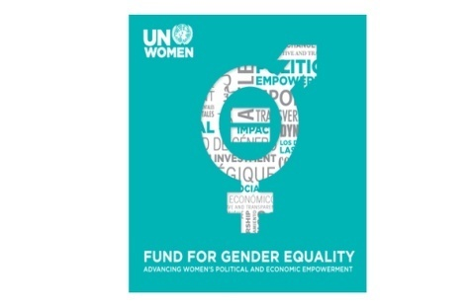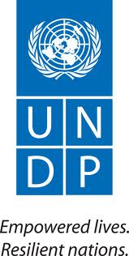
Arab Regional Training for Women, Peace, and Security
Leveraging the Engagement of Arab Women’s Rights Activists and Leaders with Relevant UN Security Council Resolutions to Advance Women’s Political Participation
APPLICATION FORM
Please complete the application form and send it to mayada@el-karama.org by May 31, 2013.
Personal History
First Name: |  |  |  | Family Name:
Office Address: |  |  |  | Home Address:
Cell Phone: (with country code) |  |  |  | Email:
Nationality: |  |  |  | Date of Birth (Day/Month/Year):
Sex: |  |  |  | Name and Phone Number (with country code) of person to be contacted in case of emergency
If accepted as a participant, will you need financial assistance for travel and accommodations?
Education (or include CV/resume)
Name & Place of Institution |  | Major fields of study |  | Degree (or years of study if non-degree)
Professional Roles | (or include CV/resume)
Name & Place of Organization |  |  | Major responsibilities
What target population does your organization serve? What are their primary needs and priorities in terms of women’s political representation and decision-making roles?
Briefly describe the programs implemented by your organization or in your other experiences that are relevant to the theme of the training
Please describe a particularly successful strategy/tool used by your organization in its work on women’s human rights and women’s empowerment
Statement of Purpose: Please briefly describe why you wish to participate in this training and what do you expect to gain from it, including how you anticipate you would replicate this training or apply it when you return home
In addition to this form, please attach a C.V. or resume and submit it with your application.

